Kyer Potts

30003389

Database Programming

AT2.1

1. How many toy products are manufactured by manufacturerID AA04 (Winnies)?
   1. SELECT COUNT(productID) FROM toyproducts WHERE manufacturerID = "AA04"
   2. 
2. How many disctinct toys are made by Meccano
   1. SELECT COUNT(productID) FROM toyproducts WHERE product_name LIKE "%Meccano%"
   2. 
3. How many toys have less than 8 items in stock
   1. SELECT COUNT(productID) FROM toyproducts WHERE in_stock < 8
   2. 
4. What is the total number of items in stock?
   1. SELECT SUM(in_stock) FROM toyproducts
   2. 
5. What is the total dollar value of all items on order?
   1. SELECT SUM(price * on_order) FROM toyproducts
   2. 
6. List all the toy products that are made from wood. Display the results by sale price ascending
   1. SELECT * FROM toyproducts WHERE product_name LIKE "%wood%" ORDER BY price ASC
   2. 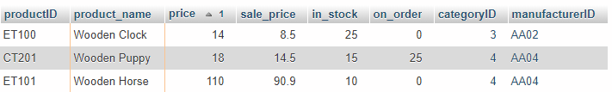
7. List all the toys in descending order based on highest sale price
   1. SELECT * FROM toyproducts ORDER BY sale_price DESC
   2. Meccano Crane
   3. 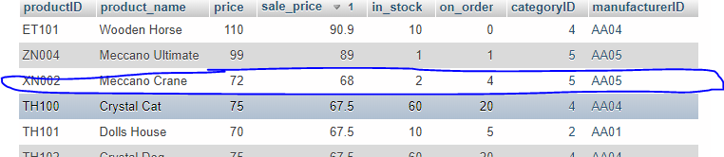
8. What is the average price of all electric toys (categoryID = 3)?
   1. SELECT AVG(price) FROM toyproducts WHERE categoryID = 3
   2. 
9. List all the distinct cities which have a toy manufacturer
   1. SELECT DISTINCT(city) FROM manufacturers
   2. 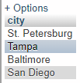
10. How many distinct stats have a toy manufacturer
    1. SELECT COUNT(DISTINCT (state)) FROM manufacturers
    2. 
11. What is the total number of toys on order
    1. SELECT SUM(on_order) FROM toyproducts
    2. 
12. What is the total number of toys in stock with a sale price greater than 20?
    1. SELECT SUM(in_stock) FROM toyproducts WHERE sale_price > 20
    2. 
13. What is the price of 11 wooden puppies? Display results as Total_Price
    1. SELECT price * 11 AS Total_Price FROM toyproducts WHERE product_name = "wooden puppy"
    2. 
14. Use the count and group functions to display the number of toys in each category. Display both the total and category ID.
    1. SELECT COUNT(productID), categoryID FROM toyproducts GROUP BY categoryID
    2. 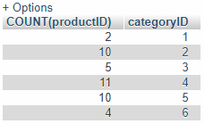
15. What is the name of the company that makes “Marbles”? Display Company Name, Product ID, Product Name, Price and number items in stock
    1. SELECT manufacturers.company_name, toyproducts.productID, toyproducts.product_name, toyproducts.price, toyproducts.in_stock FROM manufacturers, toyproducts WHERE toyproducts.product_name = "Marbles" AND manufacturers.manufacturerID = toyproducts.manufacturerID
    2. 
16. List all the companies that make dolls. Display Company Name, Product ID, Product Name, Price, and number of items in stock.
    1. SELECT manufacturers.company_name, toyproducts.productID, toyproducts.product_name, toyproducts.price, toyproducts.in_stock FROM manufacturers, toyproducts WHERE toyproducts.product_name LIKE "%doll" AND manufacturers.manufacturerID = toyproducts.manufacturerID
    2. 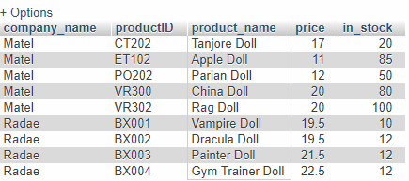
17. List all the toys which are categorised as games. Display; Category, Product Name, Sale Price.
    1. SELECT categories.categoryID, toyproducts.product_name, toyproducts.sale_price FROM categories, toyproducts WHERE toyproducts.categoryID = 5 AND categories.categoryID = toyproducts.categoryID
    2. 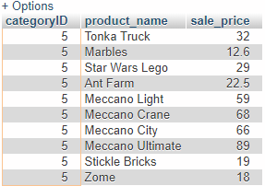
18. What is the average price and average sale price of all toys in the animal category? Use the Round functions to display the results with two decimal places. Display: Category, average price as Avg_Price, average sale price as Avg_SPrice
    1. SELECT categories.categoryID AS Category, ROUND(AVG(price), 2) Avg_Price, ROUND(AVG(sale_price), 2) AS Avg_SPrice FROM categories, toyproducts WHERE toyproducts.categoryID = 4 AND categories.categoryID = toyproducts.categoryID
    2. 
19. Display the category name, company name, product name, product ID, price and number of items in stock for the Robot Kit. (use two joins)
    1. SELECT categories.category, manufacturers.company_name, toyproducts.product_name, toyproducts.productID, toyproducts.price, toyproducts.in_stock FROM categories, manufacturers, toyproducts WHERE toyproducts.product_name = "Robot Kit" AND categories.categoryID = toyproducts.categoryID AND manufacturers.manufacturerID = toyproducts.manufacturerID
    2. 
20. List all toys made in the state “FL”, display category name, company name, product name, product ID, and price. Display the records by price ascending
    1. SELECT categories.category, manufacturers.company_name, toyproducts.product_name, toyproducts.productID, toyproducts.price FROM categories, manufacturers, toyproducts WHERE manufacturers.state = "FL" AND toyproducts.manufacturerID = manufacturers.manufacturerID AND categories.categoryID = toyproducts.categoryID
    2. 